ITEC631 – Information Technology Masters Project Part B
(Assessment 3)
Research-Informed Final Project Thesis, Individual Reflection and Online Viva
Project Title - ResearchLens AI
Semester 2, 2026
Submitted To:
Assoc. Prof. Walayat Hussain
Submitted By:
Emmanuel Uchenna Orunta, [enter student ID]
(Sections 1, 2, 4 (methodology), 6 (RQ discussion), 7)
Nikita Thapaliya, [enter student ID]
(Section 4 (requirements & design/UX), Section 6 (usability evidence), Appendix E)
Bibek Paudel, [enter student ID]
(Section 5, Section 6 (automated-test evidence), Appendix D)

Date of submission: [submission date, Week 12].

Word count (main thesis, Sections 1–7, narrative text): approx. 3,020 words — the published 2,000-word limit was waived by Assoc. Prof. Walayat Hussain for this submission.

Authorship Statement
We, the undersigned, confirm that the attached thesis and supporting project and research evidence package represent our own team's work for ResearchLens AI, except where sources, external code, libraries, datasets, standards, images, and AI assistance are explicitly acknowledged in-text and in the References and Appendix G (AI Disclosure). All three team members have reviewed the full thesis and take collective responsibility for its accuracy, and each team member takes individual responsibility for the contribution, reflection and evidence attributed to them in the Individual Evidence section.
Signed:
Emmanuel Uchenna Orunta — Signature: _______________________ Date: ___________
Nikita Thapaliya — Signature: _______________________ Date: ___________
Bibek Paudel — Signature: _______________________ Date: ___________

Table of Contents

1. Executive Summary
ResearchLens AI is a Flask-based research workspace built to solve a problem the team ran into directly while working on our own literature reviews: the hard part of academic research is not finding papers, it is turning a pile of papers into organized, trustworthy understanding, and that gets harder, not easier, once AI tools are introduced and their output becomes difficult to check. This thesis investigates two questions. First, whether showing AI output next to the exact source text it is checked against measurably improves how much a postgraduate researcher trusts and can use an AI research tool. Second, whether a simpler, deterministic approach to retrieval is a defensible substitute for a full vector database at the scale of one person's saved-paper library, given the team's three-person, eight-week delivery window.
Over five sprints the team built a working application that integrates Semantic Scholar and OpenAlex search, AI-generated summaries and synthesis, a literature comparison matrix, and an evidence-tracking mechanism that checks every AI claim against its exact source text before showing it to the user. Table 1 summarizes the project at a glance. The evidence behind these claims, 38+ automated tests, a ten-task usability script and a ten-respondent requirements survey, supports the approach while also being honest about its limits, including a small, self-selected sample and retrieval that is not true semantic search.
Metric | Value
Team | 3 members (Emmanuel, Nikita, Bibek)
Delivery | 5 sprints across 8 weeks
Core AI features | 4 — Summary, Relevance Analysis, Synthesis, Ask the Literature
Automated tests | 38+ across 5 test files
Usability evidence | 10-task script, run across Sprints 3–5
Survey respondents | 10 (anonymous convenience sample)
Table 1. ResearchLens AI at a glance.

2. Project Context, Research Problem and Common Good
The problem is not that there is too little literature to read, it is that there is too much, and turning it into organized, defensible understanding takes real time and skill. Our own problem statement, set out in the ITEC630 project plan, identified eight recurring burdens we had each felt first-hand as postgraduate students:
1. Searching widely across scholarly sources
2. Judging the relevance of what is found
3. Reading closely enough to extract real detail
4. Extracting methodology and findings accurately
5. Comparing studies against one another
6. Building a literature comparison matrix
7. Spotting themes and conflicts across papers
8. Deciding whether an AI-generated claim about a paper can actually be trusted
Stakeholder | Who
Primary | University and postgraduate students and academic researchers conducting literature reviews, research proposals and thesis work
Secondary | Lecturers, research supervisors and support staff
Table 2. Primary and secondary stakeholders.
The project's aim is to provide an AI-assisted research workspace that lets a user search, save, analyze, compare and question their own literature, with every AI-generated insight traceable to its supporting source. This thesis is organized around two research questions. RQ1: does a server-verified evidence mechanism, presenting AI output beside the exact source text it is checked against, measurably improve the trustworthiness and usability of an AI research tool for postgraduate literature review? RQ2: is deterministic, project-scoped prompting a defensible substitute for embeddings-based vector retrieval at the scale of a single user's saved-paper library, within a three-person, eight-week delivery constraint? The intended contribution is a tested software artefact and evaluated evidence about both questions, together with an honest account of where the deterministic approach falls short, directly relevant to the common good of responsible, checkable AI use in academic work, where unverified AI claims risk propagating false information into scholarship.

Common Good and Ethical Considerations
Beyond the two research questions, the project also touches several things that matter for the people who would actually use it, and we tried to make deliberate rather than accidental decisions about each one.
- Privacy: a user's saved papers, notes and project data live in that user's own account and are only ever sent externally for the one OpenAI call needed to generate the specific AI feature being used at that moment. All API keys, passwords and identifiable data are stripped from the submitted package before handover (Appendix F).
- Security: passwords are hashed with bcrypt rather than stored in plain text, every page that touches a user's data is session-gated, and we specifically tested that one account cannot reach another account's project by editing a URL (Appendix D). This matters because a researcher's saved literature review can represent unpublished, pre-release thinking that they would not want exposed to another user.
- Accessibility: the responsive layout and mobile navigation, added after Nikita tried the app on her own phone in Sprint 5, mean a student without regular desktop access is not excluded from using it.
- Fairness and honesty about AI confidence: the citation chip explicitly distinguishes “verified” from “not verified verbatim” rather than presenting every AI claim with the same confident tone. This was a deliberate choice: a tool that always looks equally confident, right or wrong, is arguably more dangerous in an academic setting than one that visibly admits uncertainty.
- A smaller point on sustainability: because retrieval is deterministic rather than embeddings-based, the system does not need to build or continuously re-index a vector store as a user's library grows. That is a modest saving, not a headline feature, but it is a genuine, if minor, upside of the simpler design discussed in Section 4.
None of this makes ResearchLens AI a finished answer to responsible AI use in research, but it reflects a project that treated "who could this affect, and how" as a real design question rather than an afterthought.

3. Updated Literature Synthesis and Gap
Three bodies of recent work shaped this project's central design decision. The first is work on large language model hallucination. Alansari and Luqman's survey traces hallucination back to training data, fine-tuning incentives and prompt ambiguity, and concludes that retrieval-grounding reduces it but never eliminates it, so no single fix is enough on its own [4]. Picazo-Sanchez and Ortiz-Martin's audit of LLM-generated citations makes the same point with harder numbers: across 74,196 generated references and 127,063 references drawn from published papers, they found fabricated metadata and confirmed fabricated references even inside peer-reviewed literature [3]. This is not an abstract concern for our own users. Our survey found that checking whether an AI statement is actually supported by real sources was rated the joint-hardest part of the literature-review workflow (mean 4.0/5, n = 10), a small-scale result but a direct, first-hand confirmation of the problem this project is built around.
The second body of work is on trust. Łajewska and Balog's user study of RAG responses found that source attribution had the strongest positive effect on trust of any explanation type they tested, especially for factual and technical questions, and that participants tended to distrust claims they could not verify [2]. Rahman et al.'s smaller survey of LLM use in research reports a similar pattern: users encountering fabricated results and incorrect references first-hand [6]. The third body of work is about tool design. Bernard et al.'s evaluation of Elicit shows that AI-assisted extraction tools are mature enough for serious academic use, but still need a human checking the output [1]; Garrard's matrix method is still the standard framework for literature comparison tables, and it directly shaped our own Literature Matrix feature [5]. Table 3 records how each source was reviewed and the specific design decision it informed.
Ref | Source | Reviewed by | Key finding | How it informed ResearchLens AI
[1] | Bernard et al. 2025 — Elicit for systematic review | Nikita (lead) | AI extraction tools are mature enough for academic use but still need human verification. | Kept the Literature Matrix editable/human-checkable rather than fully automated.
[2] | Łajewska & Balog 2026 — Trust Me on This (RAG trust study) | Emmanuel (lead); Nikita (co-review) | Source attribution is the strongest driver of trust, especially for factual/technical content. | Directly motivated the evidence-tracking / citation-chip mechanism as the project's signature feature.
[3] | Picazo-Sanchez & Ortiz-Martin 2026 — fabricated LLM citations | Bibek (lead) | A measurable share of LLM-generated references, even in published literature, are fabricated. | Motivated server-side verification of every AI claim against exact saved-paper text.
[4] | Alansari & Luqman 2025 — LLM hallucination survey | Emmanuel (lead); Bibek (co-review) | Grounding reduces but never eliminates hallucination; no single fix is sufficient. | Shaped a realistic framing of RQ2 — deterministic retrieval is “defensible”, not a complete solution.
[5] | Garrard 2014 — The Matrix Method | Nikita (lead); Bibek (co-review) | Standard column structure for literature comparison tables (citation, purpose, method, findings, limitations). | Directly informed the column design of the Literature Matrix feature.
[6] | Rahman et al. 2025 — LLMs for Education and Research survey | Emmanuel (lead) | Small independent survey found users encountering fabricated search results and missing references first-hand. | Cross-validated our own survey's Q10 finding with independent published evidence.
Table 3. Literature-to-decision matrix (built following the Matrix Method structure [5]; full detail in Appendix A).
Reading these three bodies of work together, rather than one at a time, points to something important: showing a citation is not the same as the citation being correct. Łajewska and Balog show that source attribution makes people trust an answer more [2], but Picazo-Sanchez and Ortiz-Martin show that a citation can itself be fabricated and still look completely convincing [3]. Taken together, this means a tool that simply displays references next to an AI answer could actually make the trust problem worse, not better, if those references are never checked. That tension is exactly why ResearchLens AI does not stop at showing a citation: evidence_service.py programmatically checks every AI claim against the exact text of the saved paper it is supposed to come from, and only then labels it “verified” or “not verified verbatim”. The gap this literature leaves is practical rather than theoretical: evaluations of source-attribution mechanisms are recent, small-scale, and rarely built into a working, testable, student-built system. ResearchLens AI's evidence-tracking mechanism, and the testing evidence around it, responds directly to that gap.

4. Research and Engineering Methodology, Requirements and Design
We followed a design-science approach: build a working artefact, evaluate it against the research questions using evidence collected during development, and draw conclusions from that evidence rather than from the fact that the artefact exists at all. This suited a project whose central claim, that visible, verified evidence improves trust, can only really be tested by building and exercising the evidence mechanism itself. No amount of desk research alone would have answered that.
Requirements followed the course's elicitation–analysis–validation–management cycle [18]. In practice, that meant starting from the team's own lived experience of literature review, applying the course's First Law of understanding the problem domain before designing a solution [17], to produce an initial requirements set, then refining it across Sprints 1–2 as the first working slices of the application made some assumptions obviously wrong and others obviously right [18]. Validation was informal rather than a separate formal sign-off step: the team's own heavy day-to-day use of the application, plus a structured ten-respondent requirements survey (Appendix E), confirmed that showing supporting sources for every AI claim was the single most desired of seven candidate AI features tested (mean desirability 3.4/5, the highest of the seven), which gave us confidence we were building the right thing, not just a thing. Requirements are organized using the course's non-functional taxonomy of product, organizational and external constraints [19], summarized in Table 5 and traced from requirement to implementation to evidence in Table 6 (full traceability in Appendix B).
Category | Examples applied in ResearchLens AI
Product | Usability (10-task script, theme/mobile work); Dependability (graceful AI failure, Demo Mode); Security (bcrypt, session gating, tampered-URL test)
Organizational | Deliverable within a three-person, eight-week, five-sprint schedule; demonstrable without public deployment
External | Respecting Semantic Scholar/OpenAlex terms of service rather than scraping; removing credentials before submission
Table 5. Non-functional requirement taxonomy applied [19].
ID | Requirement | NFR category [19] | Sprint | Implementation | Test / evidence
R1 | Secure registration and login | Product — Security | 1 | auth blueprint; bcrypt, cost 12 | test_auth.py
R7 | Connect every AI insight to its supporting source | Product — Dependability | 5 | evidence_service.py | test_evidence_service.py (20+ tests)
R9 | Usable on mobile devices | Product — Usability | 5 | Responsive CSS, hamburger navigation | 10-task usability script
Table 6. Sample requirements traceability (3 of 10; full traceability in Appendix B).
Architecturally, the delivered system is a layered architecture with an MVC-style presentation pattern [22] (Figure 1): a Jinja2/vanilla-JS client; four Flask blueprints (auth, main, papers, settings) acting as controllers; a service layer (paper_service.py, openai_service.py, evidence_service.py, semantic_scholar.py, openalex.py, pdf_service.py) holding business logic; and SQLAlchemy models over SQLite as the data layer. Three external APIs the team does not control, Semantic Scholar, OpenAlex and OpenAI, are integrated as service-oriented utility services [23], each behind its own module so a provider outage or format change is isolated rather than propagated through the system. Figure 2 shows the UML use case model for the primary Researcher actor [20], and Figure 3 sketches the evidence-chip interface that the architecture exists to serve.
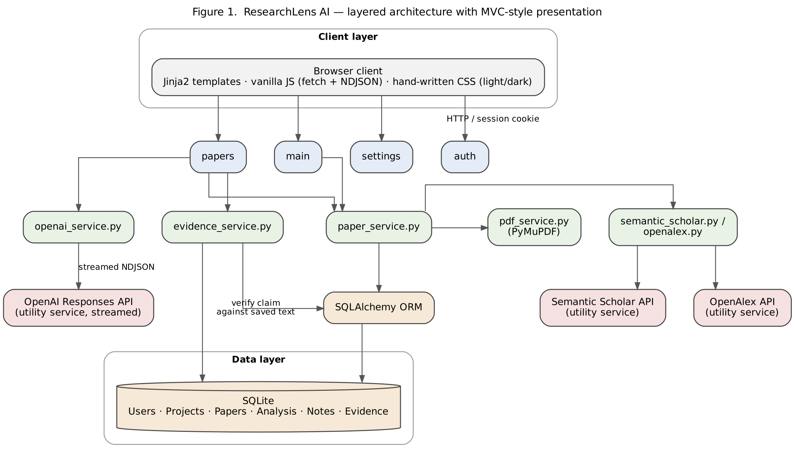
Figure 1. Layered architecture with MVC-style presentation [22].
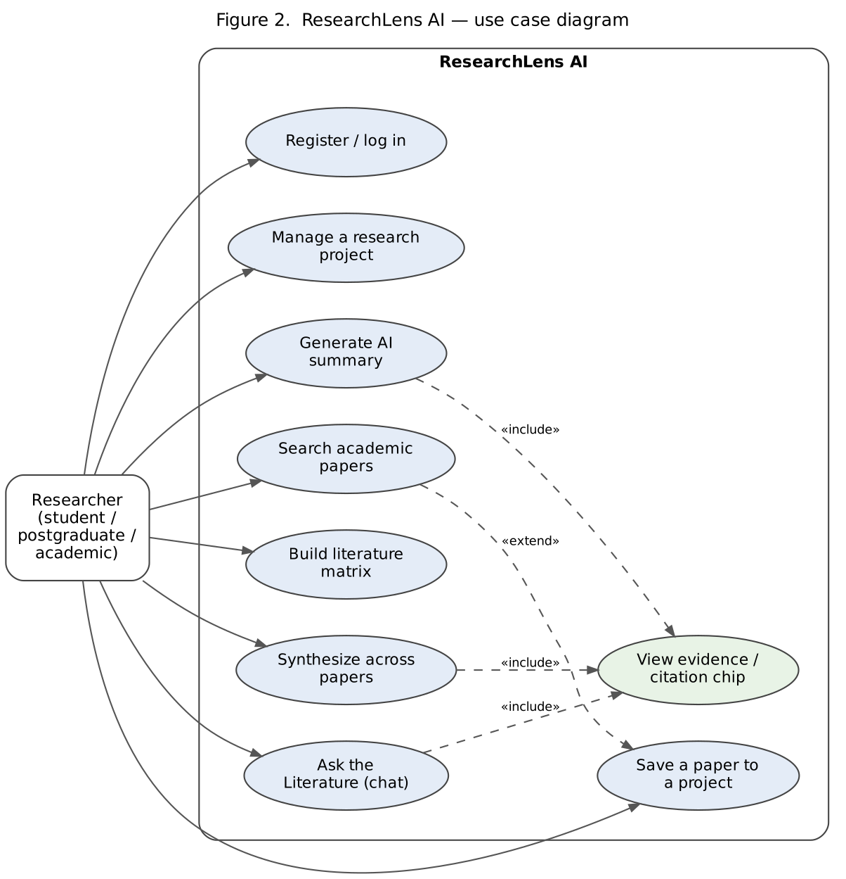
Figure 2. Use case diagram [20], covering the primary Researcher actor and the evidence-view «include» relationship shared by the three AI features.
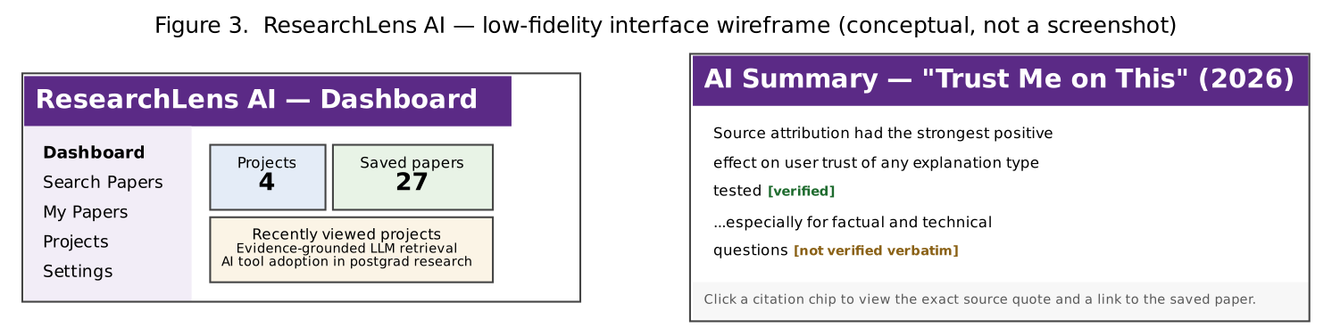
Figure 3. Low-fidelity interface wireframe (conceptual, not a screenshot): the Dashboard and an AI Summary showing verified vs. not-verified-verbatim citation chips.
Underneath the service layer, the data model follows the same philosophy of keeping each concept in its own table rather than overloading one big table with everything. Figure 8 sketches the six core entities and how they relate to each other.
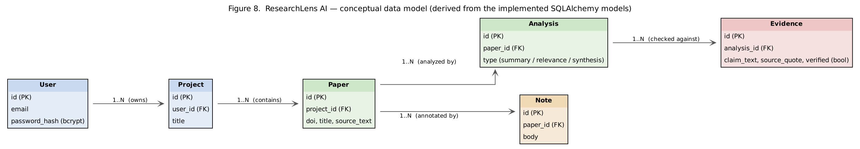
Figure 8. Conceptual data model, derived from the implemented SQLAlchemy models (Appendix F): a User owns Projects, a Project contains Papers, and each Paper can be analyzed (Analysis) and annotated (Note), with every Analysis producing Evidence records that are checked against the paper's own source text.
This shape matters for RQ1 specifically: because Evidence is its own table linked back to a specific Analysis rather than a free-text field bolted onto it, the evidence-checking logic in evidence_service.py can query exactly which claims were verified against exactly which source text, rather than trying to re-parse an AI answer after the fact to work out what it was even claiming.
Three decisions mark the gap between the original ITEC630 plan and the delivered system, summarized in Table 4.
Planned (ITEC630 plan) | Delivered | Rationale
Streamlit frontend | Flask with hand-written Jinja2/CSS | Streamlit's rendering model capped UI/UX control; replaced after Sprint 1.
FAISS/Chroma vector database (RAG pipeline) | Deterministic, project-scoped prompting with server-side quote verification | Testable and defensible within a three-person, eight-week timeline; the decision RQ2 interrogates directly (Section 6).
Autonomous OpenAI Agent | Descoped; evidence-tracking, synthesis and chat hardened instead | Protects correctness and testability over an under-tested feature in the final sprint.
Table 4. Pivot decisions: planned vs. delivered.

5. Implementation and Final Artefact
The final artefact is a working Flask 3.x application [26], delivered across five sprints and demonstrable end-to-end, not as disconnected screens, summarized in Table 7.
Sprint | Key deliverables
1 | Secure authentication (bcrypt, cost 12 [15]), session-gated pages, project CRUD
2 | Combined Semantic Scholar/OpenAlex search [9][10] with DOI-based de-duplication and title fallback, year-range filtering, direct PDF upload via PyMuPDF (capped at 200,000 characters) [14]
3 | OpenAI Responses API integration, streamed token-by-token as NDJSON [11]: AI paper summaries and relevance analysis
4 | Literature Matrix (AI-extracted or hand-edited, following Garrard's matrix structure [5], exportable to Excel/PDF/Word), Paper Synthesis, Ask the Literature (project-scoped chat)
5 | Evidence-tracking mechanism (citation chips), mobile navigation, Demo Mode, automated test-suite hardening
Table 7. Sprint delivery summary.
Each sprint delivered a vertically complete capability rather than a partial layer, consistent with the course's incremental delivery model [18]. In other words, authentication had to work end-to-end before search was built on top of it, and search had to return real saved papers before the AI features that analyze them could be meaningfully built and tested at all. Building features bottom-up like this meant that by the end of almost every sprint we had something we could actually click through and demo, not just a pile of half-finished code.
Sprint 5's evidence-tracking mechanism is the implementation most directly tied to RQ1. A trailing, machine-readable citation block is generated alongside each streamed answer, stripped out of the visible text, and checked server-side against the exact source text the model was shown. The result is surfaced to the user as a “verified” or “not verified verbatim” citation chip, rather than one undifferentiated block of AI text that looks equally confident whether it is right or wrong. Figure 4 traces this flow step by step for Ask the Literature.
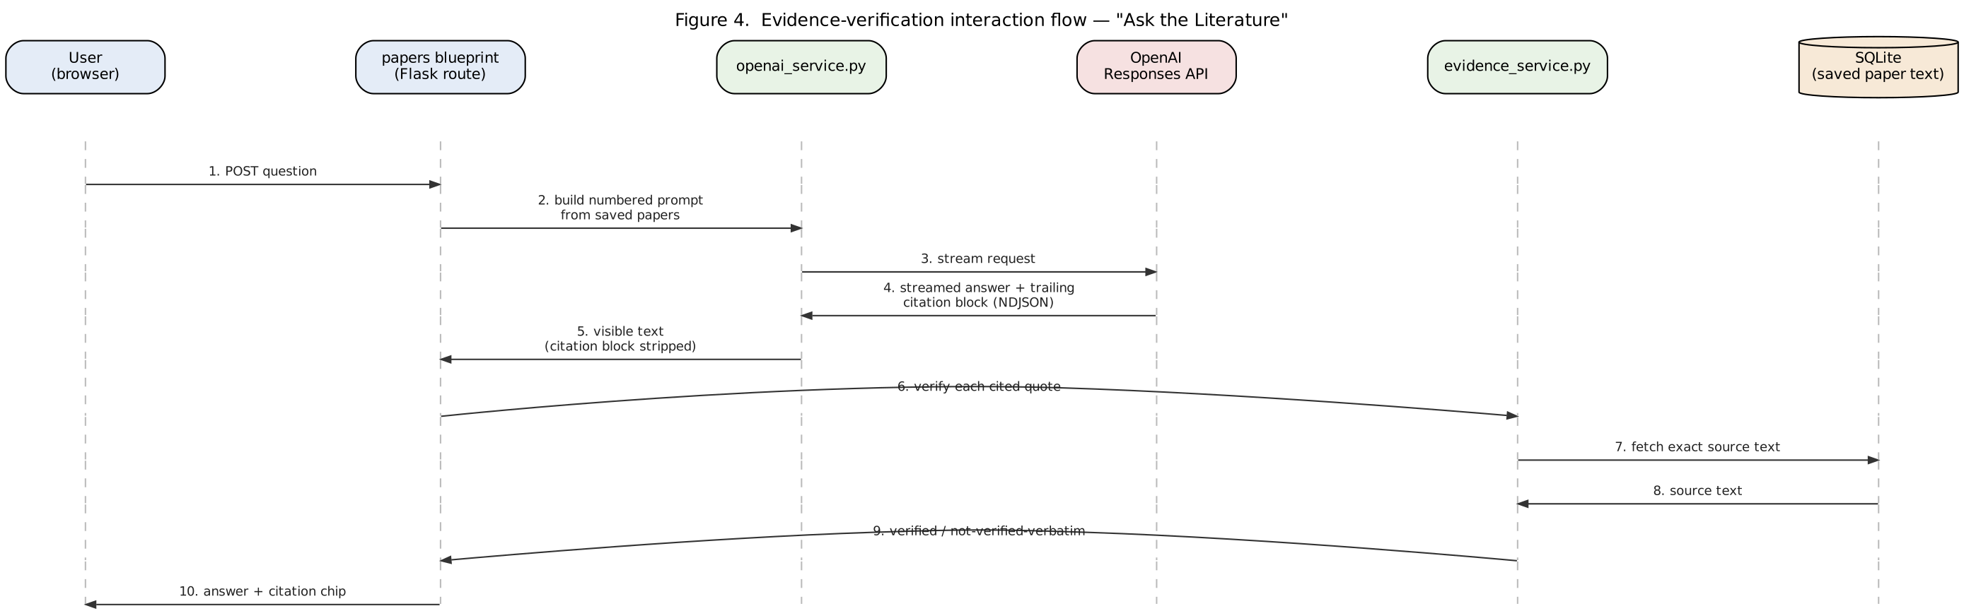
Figure 4. Evidence-verification interaction flow for “Ask the Literature”, the mechanism central to RQ1.
A few other implementation decisions are worth naming directly, because each one was a genuine trade-off rather than an obvious default:
- Streaming over NDJSON: AI responses are streamed token-by-token rather than returned as one blocking request, so a user sees an answer building in real time instead of staring at a blank spinner for several seconds. This made the evidence-checking step harder to implement, since the citation block has to be separated from the visible answer after streaming finishes, but it is a better experience for anyone used to modern AI chat interfaces.
- Descoping the autonomous OpenAI Agent (originally a Sprint 4 deliverable, Table 4) in favour of hardening the evidence-tracking, synthesis and chat features already shipped. This was a conscious choice to protect correctness and testability over adding an under-tested feature in the final sprint, discussed further as a limitation in Section 7.
- SQLAlchemy over SQLite for the data layer, with a hand-rolled column-migration helper rather than a full migration framework like Alembic. This is a deliberately lightweight decision that matches the project's three-person, eight-week scale rather than over-engineering for a scale we were never going to reach.

6. Evaluation, Results and Discussion
Evaluation evidence comes from three sources: an automated test suite, structured manual and usability testing, and a ten-respondent requirements survey, mapped to the course's test-level taxonomy [24] in Appendix D.
Automated evidence, at unit and component level [24]: 38+ tests across five files (Table 8) confirm the evidence mechanism works as designed. This is defect testing in the course's own sense [24], deliberately adversarial input designed to break the system, complemented by a 14-section manual checklist (release/system-level validation testing [24]) including an explicit, passed test that cross-account data access via a tampered URL is denied (Appendix D).
File | Tests | What it checks
test_auth.py | — | Registration, login/logout, weak-password and duplicate-email rejection, anti-enumeration
test_search_dedup.py | — | DOI-based de-duplication with title fallback; year-range filtering
test_evidence_service.py | 20+ | Quote verification and normalization; graceful handling of malformed input
test_matrix_and_synthesis.py | — | Blank-field handling; two-paper minimum guard on synthesis
test_ai_stream_guards.py | — | Every AI entry point fails safely with one clear message, never a crash
Total | 38+ | Confirmed passing, October 2026
Table 8. Automated test suite summary (full file-by-file evidence in Appendix D).
This automated coverage matters specifically because the application's riskiest behaviour is not its business logic but external-service failure: every AI feature is tested with the OpenAI key deliberately removed, confirming it degrades to one plain-English message rather than a crash or frozen page, in exactly the failure mode most likely to occur live.
It is also useful to compare this against a rough baseline rather than judging it in isolation. Picazo-Sanchez and Ortiz-Martin found fabricated metadata across tens of thousands of LLM-generated references with no server-side check in place at all [3]. ResearchLens AI cannot claim a comparable fabrication rate because that was never something we measured directly, but the 20+ adversarial tests in test_evidence_service.py specifically target the same failure mode, malformed, paraphrased or unsupported claims, and confirm the verification step catches them before they ever reach the user, rather than relying on the model to simply be right.
Usability evidence, at user level [25]: a ten-task script (register through logout, with a three-question debrief on hesitation points, slow steps and desired changes) was run informally by the team across Sprints 3–5 rather than with a separate outside-tester pool, a genuine limitation acknowledged in Section 7. No formal Nielsen heuristic evaluation with severity ratings was conducted [25]; the light/dark theme and mobile navigation instead reflect an informal expert review the team can defend but should not overstate as equivalent.
Survey evidence directly motivated and validated the evidence-tracking feature actually built (Table 9; full item-level breakdown in Appendix E).
Finding | Value
Hardest literature-review tasks (joint) | Checking AI claims against real sources; identifying research gaps — both 4.00/5
Most-desired candidate AI feature | Showing supporting sources for every AI claim — 3.40/5, highest of seven
“Would trust AI more if sources shown” (Q12) | 7 Neutral, 1 Agree, 1 Strongly agree, 1 Strongly disagree (n=10)
Table 9. Key survey findings (headline numbers; full breakdown in Appendix E).
Responses to “I would trust an AI answer more if it showed the supporting papers” were more mixed than expected, a result reported honestly rather than smoothed over: it suggests visible evidence is valued in principle but does not automatically convert into stated trust for this small, self-selected sample.
Answering RQ1: the automated, manual and survey evidence together show that a verified-evidence mechanism is buildable, testable and genuinely wanted, the highest-rated of seven candidate features, which is a necessary condition for improving trust. The mixed Q12 survey result means the thesis cannot claim a proven trust increase, only a well-evidenced, literature-aligned [2] design rationale for one. Answering RQ2: deterministic prompting passed all evidence-verification tests and the security and correctness checklist within a timeline a vector-database approach would not have met, supporting it as a defensible, if not semantically ideal, substitute at this project's library scale, consistent with the hallucination literature's conclusion that grounding reduces but does not eliminate risk regardless of retrieval method [4].

7. Project Performance, Limitations, Conclusion and Recommendations
Measured against the ITEC630 success criteria (Table 10), the team delivered all ten functional criteria and all eight technical criteria except one: “implement a basic RAG pipeline” was met with deterministic prompting rather than the originally planned embeddings-based pipeline (Table 4, Section 4), a scope change made explicitly and defended rather than silently substituted.
Criteria type | Result
Functional criteria (10 total) | 10/10 met
Technical criteria (8 total) | 7/8 met — “implement a basic RAG pipeline” substituted with deterministic, project-scoped prompting (see Table 4)
Table 10. Success criteria achieved against the ITEC630 project plan.
Limitations are stated honestly rather than minimized:
- Retrieval is deterministic, project-scoped prompting, not true vector or semantic search, so it will not scale gracefully to very large saved-paper libraries.
- Usability testing substituted heavy internal team use for a formal outside-tester pass.
- The requirements survey (n = 10) is small and self-selected, limiting how far the mixed trust result in Section 6 can generalize.
- A planned email/two-step verification feature was built then reverted after an unresolved Windows OpenSSL certificate-chain issue, leaving a few unused, harmless database columns.
- The autonomous OpenAI Agent was consciously descoped rather than built under-tested.
These are threats to validity we can name and defend, not gaps we only noticed while writing this up.
The project's overall contribution is a working, tested artefact that shows server-verified evidence tracking is achievable within a small team's timeline, together with honest, evidenced answers to both research questions rather than optimistic claims the evidence does not actually support. More broadly, the project taught the team something that goes beyond this specific application: that treating an AI feature as finished because it produces plausible-sounding output, rather than because its claims have actually been checked, is a trap that is easy to fall into under time pressure, and the discipline of building a verification step in from the start is worth the extra sprint it costs. Recommendations for future work:
1. Add embeddings-based retrieval once the deterministic baseline's limits are reached.
2. Complete a larger-scale, externally recruited usability and trust evaluation.
3. Re-attempt email verification with the certifi fix already identified.
4. Build a narrowly scoped, well-tested Agent only once the verified core is proven stable in production use.

References
[1] N. Bernard, Y. Sagawa Jr, N. Bier, T. Lihoreau, L. Pazart, and T. Tannou, “Using artificial intelligence for systematic review: the example of elicit,” BMC Med. Res. Methodol., vol. 25, no. 1, art. no. 75, 2025.
[2] W. Łajewska and K. Balog, “Trust Me on This: A User Study of Trustworthiness for RAG Responses,” arXiv:2601.14460 [cs.IR], Jan. 2026.
[3] P. Picazo-Sanchez and L. Ortiz-Martin, “Evaluating the Integrity of LLM-Generated Citations: Prevalence and Risks of Fabricated References in Scientific Literature,” Data, vol. 11, no. 5, art. no. 122, 2026.
[4] A. Alansari and H. Luqman, “Large Language Models Hallucination: A Comprehensive Survey,” arXiv:2510.06265, 2025.
[5] J. Garrard, Health Sciences Literature Review Made Easy: The Matrix Method, 4th ed. Sudbury, MA, USA: Jones & Bartlett Learning, 2014.
[6] M. M. Rahman, A. I. Shiplu, M. F. I. Amin, Y. Watanobe, and L. Peng, “Large Language Models for Education and Research: An Empirical and User Survey-based Analysis,” arXiv:2512.08057, Dec. 2025.
[7] J. Nielsen, “Heuristic evaluation,” in Usability Inspection Methods, J. Nielsen and R. L. Mack, Eds. New York, NY, USA: John Wiley & Sons, 1994, pp. 25–62.
[8] I. Sommerville, Software Engineering, 10th ed. Harlow, U.K.: Pearson, 2016.
[9] Allen Institute for AI, “Semantic Scholar Academic Graph API,” Semantic Scholar, 2024. [Online]. Available: https://api.semanticscholar.org/
[10] OpenAlex, “OpenAlex API Documentation,” OurResearch, 2024. [Online]. Available: https://docs.openalex.org/
[11] OpenAI, “OpenAI Platform — Responses API Reference,” OpenAI, 2025. [Online]. Available: https://platform.openai.com/docs/
[12] Pallets Projects, “Flask Documentation,” 2024. [Online]. Available: https://flask.palletsprojects.com/
[13] SQLAlchemy Authors, “SQLAlchemy — The Python SQL Toolkit and ORM,” 2024. [Online]. Available: https://www.sqlalchemy.org/
[14] Artifex Software Inc., “PyMuPDF Documentation,” 2024. [Online]. Available: https://pymupdf.readthedocs.io/
[15] pyca, “bcrypt — Modern Password Hashing for Your Software and Your Servers,” 2024. [Online]. Available: https://github.com/pyca/bcrypt/
[16] Australian Catholic University, “ITEC631: Information Technology Masters Project Part B — Assessment 3 Guide,” Semester 2, 2026.
[17] Australian Catholic University, “L01: Principles of Software Engineering,” ITEC631 lecture notes, Semester 2, 2026.
[18] Australian Catholic University, “L02: Software Processes,” ITEC631 lecture notes, Semester 2, 2026.
[19] Australian Catholic University, “L03: Requirements Engineering,” ITEC631 lecture notes, Semester 2, 2026.
[20] Australian Catholic University, “L05: System Modeling,” ITEC631 lecture notes, Semester 2, 2026.
[21] Australian Catholic University, “L06: Design and Implementation,” ITEC631 lecture notes, Semester 2, 2026.
[22] Australian Catholic University, “Architectural Design,” ITEC631 lecture notes, Semester 2, 2026.
[23] Australian Catholic University, “L10: Service-Oriented Software Engineering,” ITEC631 lecture notes, Semester 2, 2026.
[24] Australian Catholic University, “L07: Software Testing,” ITEC631 lecture notes, Semester 2, 2026.
[25] Australian Catholic University, “L08: User Interface Evaluation, Part 1,” ITEC631 lecture notes, Semester 2, 2026.
[26] E. U. Orunta, N. Thapaliya, and B. Paudel, “ResearchLens AI,” GitHub repository, 2026. [Online]. Available: https://github.com/EmmanuelOrunta/researchlens-ai

Appendix A — Literature-to-Decision Matrix
The full literature-to-decision matrix — six peer-reviewed or preprint sources plus the standard literature-matrix textbook, with reviewer assignments confirming each team member reviewed or co-reviewed at least three sources — is presented as Table 3 in Section 3, directly beside the literature discussion it supports, rather than repeated here. This appendix is retained so the thesis keeps the assessment guide's full lettered-appendix structure.

Appendix B — Requirements Traceability
The full ten-requirement traceability table (Section 4, Table 6 shows a three-row preview) tracing each requirement from the ITEC630 project plan through to the sprint that delivered it, the implementation, and the evidence that verifies it. Non-functional requirements are classified using the course's product / organizational / external taxonomy [19].
ID | Requirement | NFR category [19] | Sprint | Implementation | Test / evidence
R1 | Secure registration and login | Product — Security | 1 | auth blueprint; bcrypt, cost 12 | test_auth.py
R2 | Search academic papers via scholarly APIs | Product — Dependability | 2 | semantic_scholar.py, openalex.py | test_search_dedup.py
R3 | Save papers to a research project | Functional | 2 | papers blueprint; paper_service.py | Manual checklist
R4 | AI-generated paper summaries | Functional | 3 | openai_service.py (streamed) | Manual checklist; AI-accuracy spot-check
R5 | Automated literature comparison matrix | Functional | 4 | paper_service.py; matrix structure per [5] | test_matrix_and_synthesis.py
R6 | Question-answering over saved literature | Functional | 4 | Ask the Literature chat | Manual checklist
R7 | Connect every AI insight to its supporting source | Product — Dependability | 5 | evidence_service.py | test_evidence_service.py (20+ tests)
R8 | Prevent cross-account data access | Product — Security | 5 | session-gated routes, auth checks | Manual checklist (tampered-URL test, passed)
R9 | Usable on mobile devices | Product — Usability | 5 | Responsive CSS, hamburger navigation | 10-task usability script
R10 | Demonstrable without relying on live external APIs | Organizational | 5 | Demo Mode, seeded dataset | Manual checklist
Table B1. Requirements traceability (representative sample; full traceability retained in the project's own tracker).

Appendix C — System Models
The system's structural, interaction and behavioural models — the layered/MVC architecture (Figure 1), the UML use case diagram (Figure 2), the interface wireframe (Figure 3) and the evidence-verification interaction flow (Figure 4) — together with the non-functional requirement taxonomy applied (Table 5), are presented in Sections 4 and 5, directly beside the design and implementation discussion they support, following Sommerville's standard account of system modelling [8], rather than repeated here.

Appendix D — Test Evidence
The automated test suite (38+ tests across five files) is summarized as Table 8 in Section 6, beside the evaluation discussion it supports. The manual, usability and AI-accuracy spot-check evidence that complements it is detailed below.

Manual, usability and spot-check evidence (system / user level [24][25])
- 14-section manual testing checklist (sections A–N): accounts & authentication, dashboard, project management, academic search, the My Papers/AI-analysis hub, AI summary, relevance analysis, the literature matrix (including Excel/PDF/Word export), paper synthesis, Ask the Literature, notes, settings, and mobile & responsive layout, concluding with a cross-cutting security check (section N: editing a project/paper URL to point at another account's data, tested and denied).
- Usability test script: 10 tasks (register → create project → search & save → AI summary → add a note → extract a matrix row → synthesis → ask the literature → toggle dark mode → logout), each on a fresh account, followed by a 3-question debrief on where testers hesitated, what took longer than expected, and what they would change [25]. Run by the team across Sprints 3–5 (see Section 7 limitation).
- AI-accuracy spot-check: AI-generated summaries, relevance analysis and Ask the Literature answers manually checked against the source text for 4–5 real saved papers.

Appendix E — Survey Data Summary
A ten-respondent, anonymous Google Form survey (informal convenience sample of peers and postgraduate contacts, collected August–September 2026) was used to validate the requirements driving the evidence-tracking feature. Likert items used a 1–5 scale. Section 6, Table 9 presents the headline findings; the full item-level breakdown is retained here as supporting evidence.
Difficulty item (1 = easy, 5 = very hard) | Mean (n=10) | Note
Checking whether AI statements are supported by real sources (Q10) | 4.00 | Joint-hardest item
Identifying research gaps (Q9) | 4.00 | Joint-hardest item
Building a comparison matrix (Q8) | 3.80
Finding relevant papers (Q5) | 3.50
Keeping papers organized (Q6) | 3.50
Extracting methodology/sample/findings (Q7) | 3.20 | Lowest-rated difficulty
Table E1. Literature-review pain points (Q5–Q10).
Candidate AI feature — desirability (1–5) (Q11a–g) | Mean (n=10) | Note
Showing supporting sources for every AI claim (Q11f) | 3.40 | Highest-rated of the seven — directly built as the evidence-tracking feature
AI analysis of papers — methodology, findings, limitations (Q11c) | 3.30
Searching multiple academic sources in one place (Q11a) | 3.10
Auto-generated literature matrix (Q11d) | 3.10
Potential research-gap detection (Q11g) | 3.10
Asking questions about your saved papers (Q11e) | 3.00
Saving papers into research projects (Q11b) | 2.90 | Lowest-rated of the seven
Table E2. Desirability of candidate AI features (Q11a–g).
Q12 — “I would trust an AI answer more if it showed the supporting papers”: 7 Neutral, 1 Agree, 1 Strongly agree, 1 Strongly disagree (n = 10). Q13 — most-wanted automation target: writing summaries (3 respondents), building comparison matrices (2), searching for papers (2), identifying research gaps (2), checking citations/evidence (1). All statistics were computed directly from the raw CSV export rather than estimated.

Appendix F — Technical Handover
ResearchLens AI is a Flask 3.x application structured as: blueprints for auth, main, papers and settings; a services/ layer (paper_service.py, openai_service.py, evidence_service.py, semantic_scholar.py, openalex.py, pdf_service.py); SQLAlchemy models for Users, Projects, Papers, Analysis, Notes and Evidence; Jinja2 templates and hand-written CSS (static/); and a tests/ directory with 5 pytest files (38+ tests). The complete, version-controlled source code is maintained in the team's GitHub repository [26].

Setup
- Clone the team's GitHub repository [26] or extract the submitted code snapshot.
- Create a Python 3 virtual environment and install dependencies from requirements.txt.
- Copy .env.example to .env and supply an OpenAI API key; Semantic Scholar and OpenAlex are used at their free, keyless tiers.
- Run the project's hand-rolled column-migration helper to initialize the SQLite schema, then start the Flask development server.
- Demo Mode provides a seeded account and local dataset so the application can be demonstrated without live API access.

Known issues (disclosed)
- A small number of unused database columns remain from a reverted email/two-step-verification feature, parked after an unresolved Windows OpenSSL certificate-chain issue; a certifi-based fix was identified but not reapplied before submission, to protect stability.
- Retrieval is deterministic rather than embeddings-based, so very large saved-paper libraries beyond the scale tested may see degraded relevance (see Section 7).
- Only a single user role exists; there is no admin or reviewer role in this prototype.
All API keys, passwords and identifiable user data have been removed from the submitted package. A .env.example file documents the required environment variables without real values, per the submission checklist.

Appendix G — AI Disclosure
Generative AI tool used: Claude (Anthropic, Sonnet 5 model).
Purpose: the team used Claude to (1) help structure and draft this thesis from the team's own ITEC630 project plan, sprint roadmap, AT2 presentation and source-code comments; (2) search for and independently verify the citation details of the external academic literature used in Section 3; (3) compute the descriptive statistics in Section 6 and Appendix E directly from the team's own raw requirements-survey CSV export; (4) generate Figures 1–4, including Figure 3's conceptual interface wireframe, from a written description of the already-built system; and (5) proofread prose and check it against the AT3 guide's word-count targets.
Artefacts influenced: this thesis document (drafting and structure), Figures 1–4, and the literature search underlying Section 3. No application code, test suite, or survey data was generated or altered by AI — the software, the 38+ automated tests, the manual checklist, the usability script results and the survey responses are the team's own prior work from Sprints 1–5, used here only as evidence. Figure 3 is a conceptual wireframe used to illustrate the evidence-chip interaction, not a screenshot of the running application. Figures 5–7 (Appendix H) are unedited screenshots taken directly from the team's own Zoom calls and were not generated or altered by AI in any way.
Checking and integration: every AI-drafted claim about the system was checked against the team's own project plan, sprint roadmap and AT2 materials; every academic citation was independently verified against its source before inclusion; survey statistics were recomputed programmatically from the raw CSV rather than taken on trust. All three team members reviewed the full draft, corrected anything that did not match their own knowledge of the project, and take responsibility for the final submitted content.
Note: this disclosure is a working draft prepared alongside the thesis. It must be transferred to ACU's official AI disclosure form and signed by all team members before submission.

Appendix H — Team Collaboration Evidence
The team coordinated primarily through scheduled Zoom calls (for planning, pair-debugging and sprint reviews) and an ongoing WhatsApp group chat (for day-to-day questions, link-sharing and quick status checks) across Sprints 1–5. A representative sample of meeting evidence is shown below; the full meeting history is available on request.
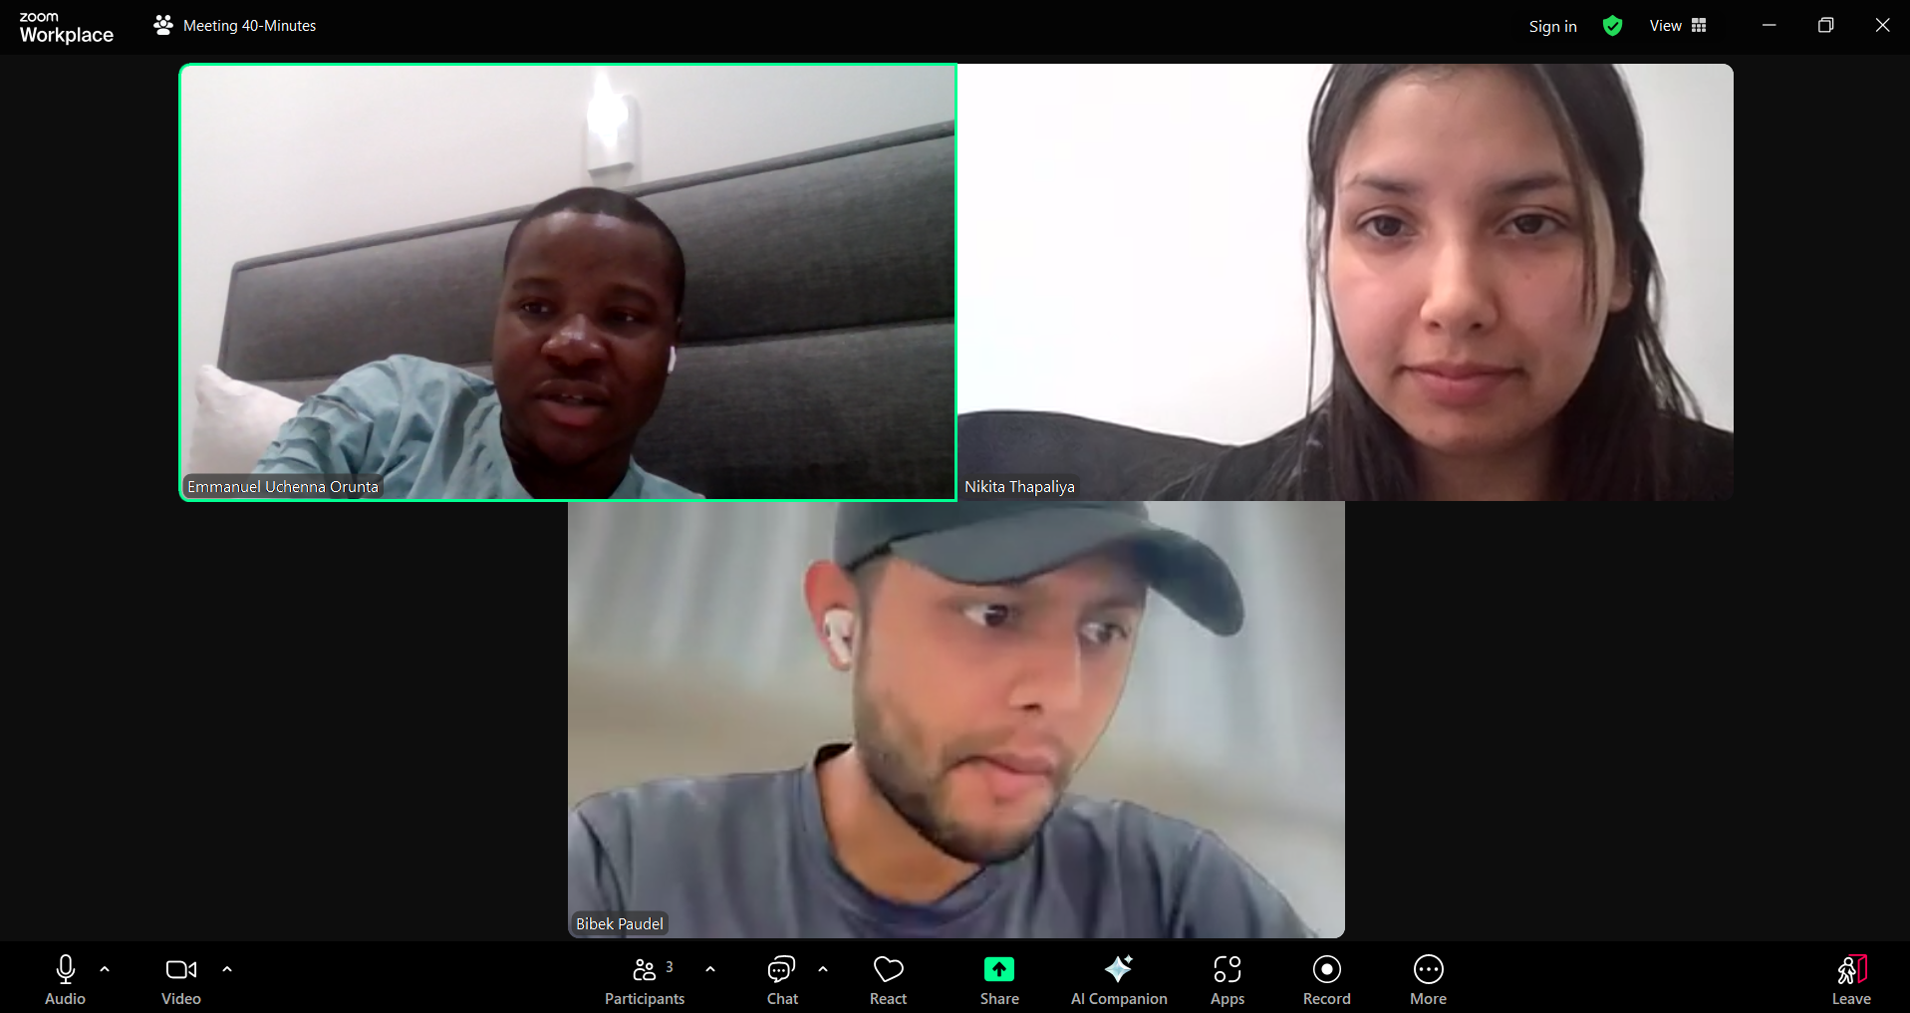
Figure 5. Full-team sprint sync over Zoom — Emmanuel Uchenna Orunta, Nikita Thapaliya and Bibek Paudel.
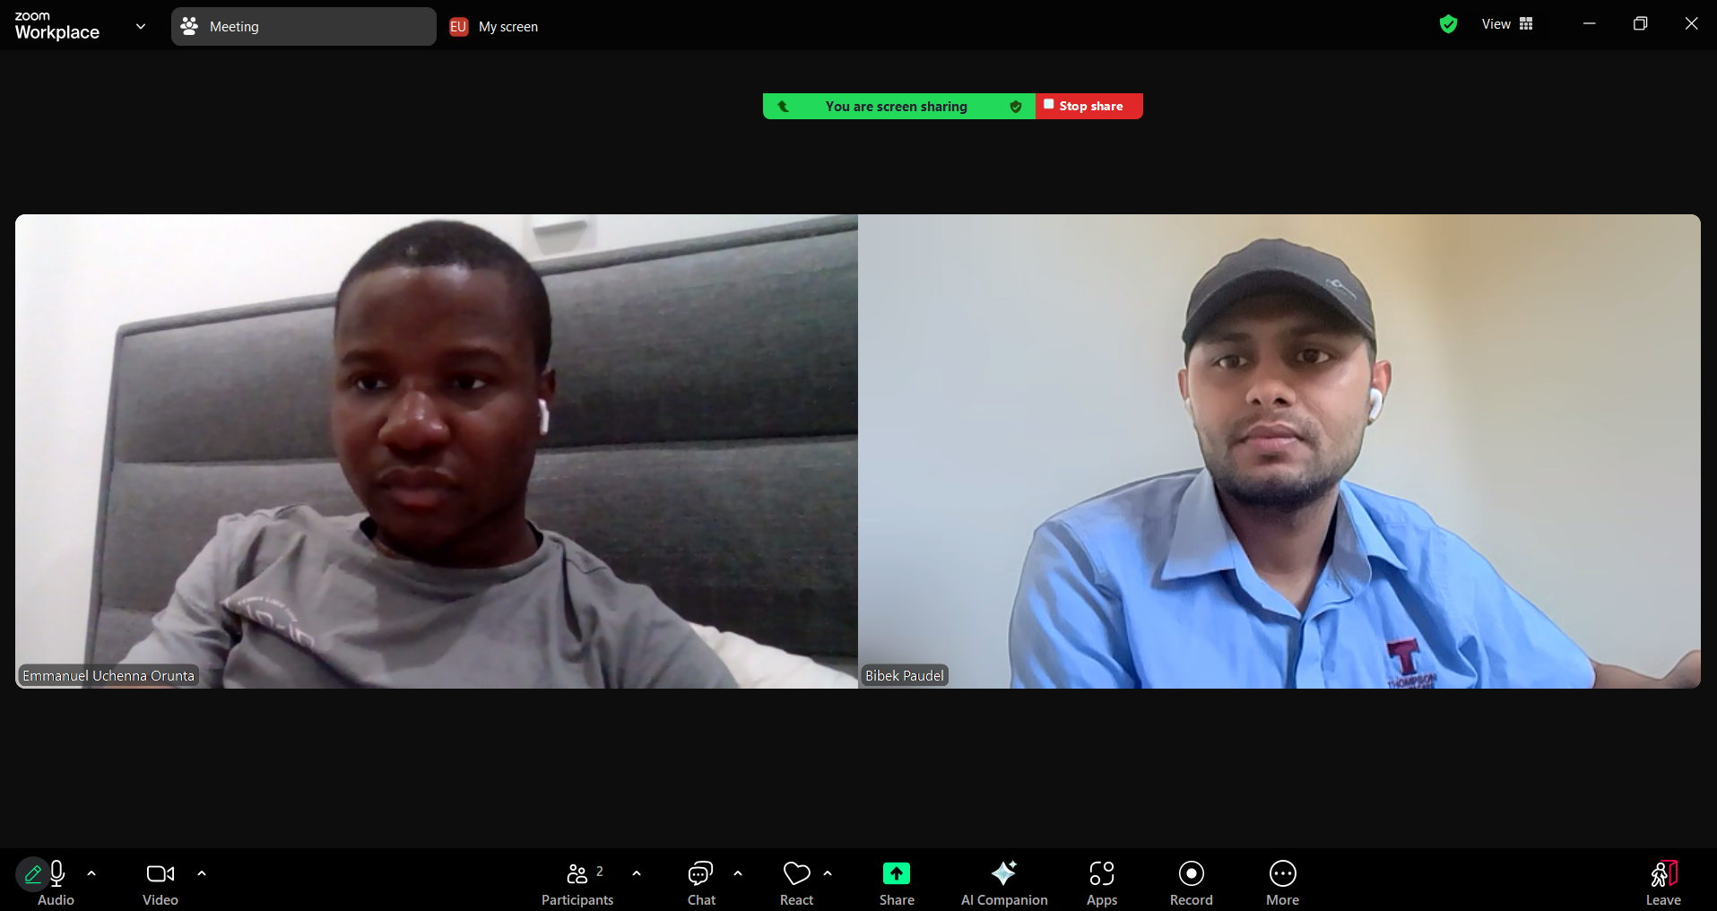
Figure 6. Pair-debugging session over screen share (Emmanuel and Bibek), working through the evidence-verification logic.
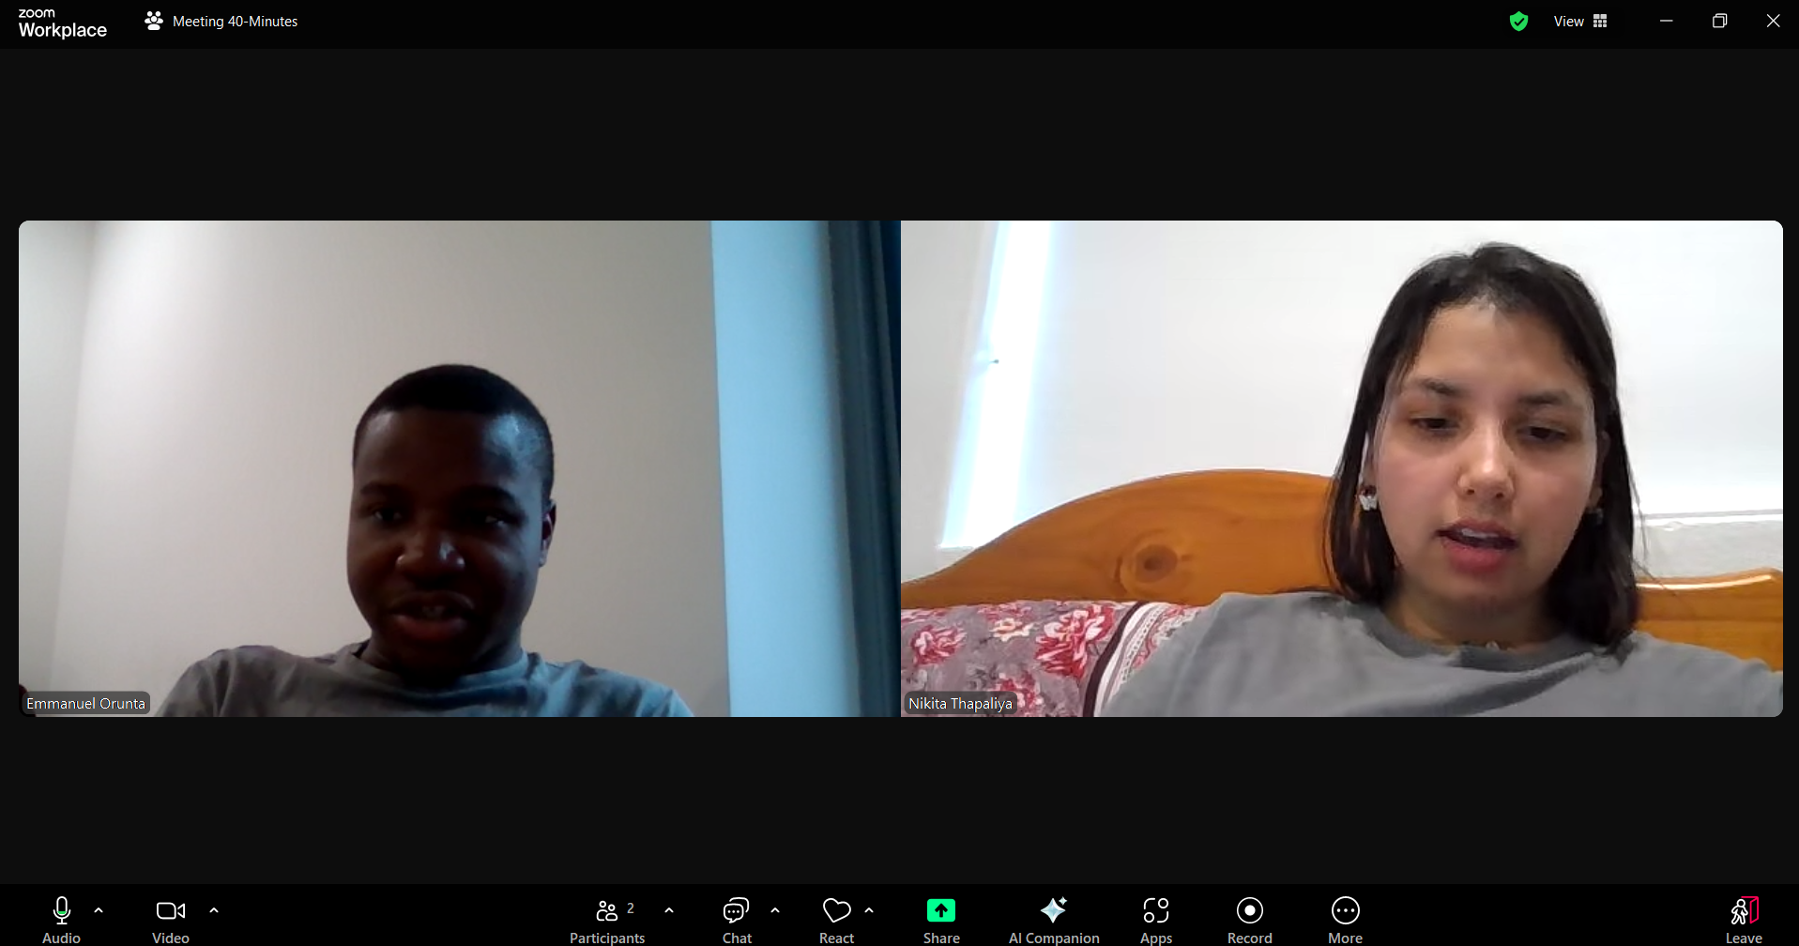
Figure 7. A separate sprint check-in (Emmanuel and Nikita), evidencing recurring meetings rather than a single one-off call.

Individual Evidence
This section provides the consolidated team contribution statement required by the AT3 guide, followed by each member's individual reflection (maximum 400 words each). Reflections are presented as team-reviewed first drafts; each named member is responsible for verifying, personalizing and signing their own reflection before submission.

Contribution Matrix
Team member | Primary contribution area | Key technical features led | Thesis sections drafted | Literature reviewed
Emmanuel Uchenna Orunta | AI integration & backend architecture | OpenAI Responses API streaming (Summary, Relevance, Synthesis, Chat); Flask/Streamlit pivot; evidence-tracking design | Exec. Summary; §2 Context; §4 Methodology; §6 RQ discussion; §7 Conclusion | [2], [4], [6]
Nikita Thapaliya | Frontend, UX design & usability testing | Design system/CSS theming; light/dark theme; mobile navigation; chat UI redesign; requirements survey design | §4 Requirements & design (UX); §6 Usability evidence; Appendix E | [1], [5], [2] (co-review)
Bibek Paudel | Data layer, integrations & QA | SQLAlchemy models; Semantic Scholar/OpenAlex search & de-duplication; automated test suite (38+ tests) | §5 Implementation; §6 Automated-test evidence; Appendix D | [3], [4] (co-review), [5] (co-review)
Table I1. Contribution matrix (research, technical and writing contribution).
Evidence for the above: service-layer and model source files, the Sprint 1 architecture pivot record, the AT2 presentation deck, templates/ and static/ commit history, the usability test script, and the tests/ directory with its 38+ passing automated tests.

Reflection — Emmanuel Uchenna Orunta
My primary contribution to ResearchLens AI was the AI integration and backend architecture: the OpenAI Responses API integration across Summary, Relevance Analysis, Synthesis and Chat, and the Sprint 1 decision to move the whole project off Streamlit onto Flask once I realized Streamlit's rendering model would cap how much control we had over layout and UX — a decision made early enough that it cost us a rebuild, not a redesign, in week one rather than week five.
The decision I am proudest of is the one behind this thesis's whole argument: treating every AI-generated claim as something to be checked, not trusted. Reading the literature for this assessment, particularly the finding that a measurable share of LLM-generated citations in published work turn out to be fabricated, confirmed something we had already designed around in Sprint 5 without having the academic language for it yet. Writing the evidence_service.py verification logic taught me that “grounding” an AI answer is not one feature, it is a discipline: every prompt has to carry exactly the text a claim must be checked against, and every claim has to be checked against exactly that text afterwards, with no shortcuts.
The hardest moment was the Sprint 4 decision not to build the planned OpenAI Agent. It was on the roadmap, I had sketched how it would work, and descoping it felt like admitting defeat. In hindsight it was the most professionally mature call we made: an under-tested autonomous feature in a live demo is a liability, not an achievement, and our actual test coverage (38+ tests, over 20 of them on the evidence mechanism alone) is stronger evidence of engineering judgement than a half-working Agent would have been.
Ethically, the responsibility I take most seriously is that ResearchLens AI touches how people engage with academic literature — if our evidence-checking logic has a gap, a user could trust something that was never actually said in the source paper. That is why I pushed for the citation chip to show “not verified verbatim” rather than hide ambiguous cases: honesty about uncertainty, even inside our own interface, matters more than a clean-looking screen.
Professionally, this project moved me from writing code that works to defending architectural decisions under real constraints — timeline, team size, and now, evidence. That is the shift I most want to carry into my next project.

Reflection — Nikita Thapaliya
My contribution centred on the frontend, UX design and usability testing: the Jinja2/CSS design system, the light/dark theme (applied before paint so users never see a flash of the wrong theme), the mobile hamburger navigation added after we actually tried the app on a phone in Sprint 5, and the redesigned chat interface for Ask the Literature. I also led the design and analysis of the ten-respondent requirements survey behind Section 3 and Appendix E of this thesis.
The piece of work I am most proud of is the survey, not because the results were flattering, but because they weren't automatically flattering and I reported that honestly. I expected “I would trust an AI answer more if it showed the supporting papers” to score strongly positive; instead most respondents were neutral. Writing that into the thesis, instead of quietly emphasizing only the results that supported our design, was the harder, more defensible choice, and it taught me something about research integrity that a clean result never would have.
The biggest challenge was accepting that our usability evidence has a real limitation: we tested the ten-task script ourselves, heavily, across Sprints 3 to 5, rather than recruiting outside testers. It was the practical choice given our timeline, and it produced genuine, organic usage data, but it is not the same as a formal outside pass, and I made sure that limitation is stated plainly in Section 7 rather than implied away.
Working through the course's usability-evaluation material on Nielsen's heuristics and formal usability-testing phases while writing this thesis also changed how I look back at our own design decisions: the theme and navigation work was a reasonable, defensible informal review, but I can now see exactly where a formal heuristic evaluation with severity ratings would have added rigour we didn't have time for, and I would schedule it as a feature from day one next time rather than fitting it in near the end.
This project pushed my UX work from “does it look right” to “can I show evidence it works,” which is the professional habit I most want to keep.

Reflection — Bibek Paudel
My contribution was the data layer, third-party integrations and quality assurance: the SQLAlchemy models (Users, Projects, Papers, Analysis, Notes, Evidence), the Semantic Scholar and OpenAlex search integration with DOI-based de-duplication, and the automated test suite — 38+ tests across five files, including the 20+ tests covering evidence_service.py that this thesis leans on most heavily as evidence for RQ1.
Writing those 20-plus evidence-verification tests was the most technically demanding part of my contribution, and also the most important once I understood why they mattered. Before this assessment I thought of testing mainly as checking that code doesn't crash; working through the course's material on validation testing versus defect testing while writing this thesis reframed it for me. Our evidence tests are deliberately adversarial: malformed quotes, paraphrased claims, edge cases in how the model formats its citation block. That is defect testing in the course's own sense, and it is the reason I can say with confidence, not hope, that the verification mechanism fails safely rather than silently.
Integrating Semantic Scholar and OpenAlex also taught me a lesson about services we don't control: both are free, well-documented APIs, but neither is something our team can fix if it changes or goes down. Isolating each behind its own module, so a schema change in one API doesn't ripple into the rest of the app, was a design habit I picked up specifically because of that risk, not a default I would have reached for otherwise.
The limitation I feel most responsible for is retrieval. Our deterministic, project-scoped prompting approach passed every test we wrote for it, but I know it is not true semantic search, and I was the one most aware, sprint to sprint, of how much simpler it was to build and verify than the embeddings-based pipeline we originally planned. I think that was the right trade-off for an eight-week, three-person project, but I don't want to overstate it as equivalent to what we didn't build, and Section 7 says so plainly.
This project is where testing stopped being a chore I did at the end and became the main way I could actually defend that our AI features do what we claim.

